S5GC Ref No. | For internal S5GC use only

Expression of Interest Application

Deadline: Wednesday 18th May 9.30am

Submit Application: dan.langford@scotland5gcentre.org

Any questions? dan.langford@scotland5gcentre.org or Tim.Marsden@scotland5gcentre.org

FAQs: Available on www.scotland5gcentre.org

PART 1 ABOUT THE COMPANY

Company Name
Company Reg Number
Contact Name
Position
Trading Address
Registered Address (if different)
Telephone
Email
Web address
Turnover in last financial year
Number of Employees
Company SIC Number

PART 2 PROJECT SUMMARY

1. What are your goals and objectives in joining the Innovation Challenge: (150 words)

2. How does the project address one of the 3 proposed Innovation Challenges? (150 words)

3. What is the current Technology Readiness Level of your solution? Describe how you defined the current Technology Readiness Level of your solution. (150 words)

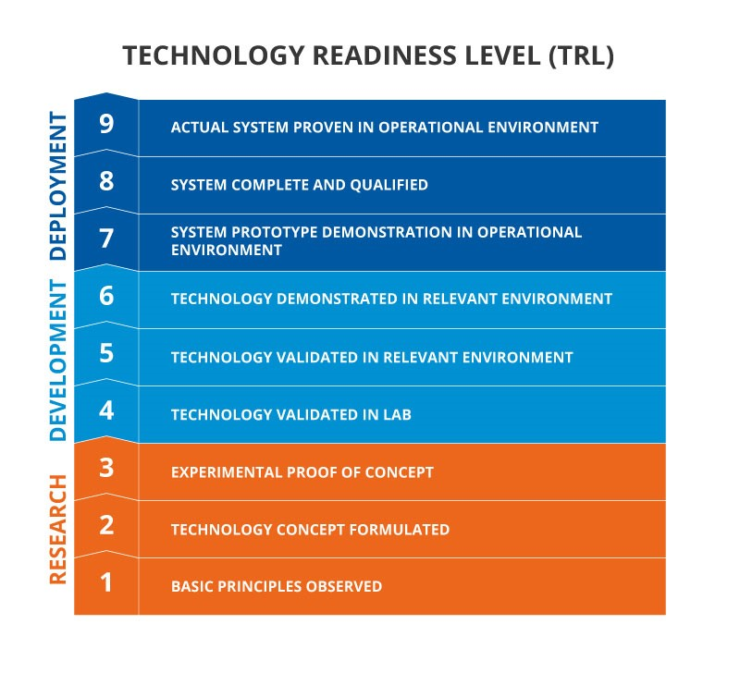
4. Has your solution been tested outside of the development environment? Describe the kind of tests completed outside your development environment. (200 words)

5. Is your solution currently deployed to users or customers? How many current users?

6. How many days can your team dedicate to the project if you are selected in order to participate in the challenge? List the people and their proposed role within the challenge. (150 words)

7. With the challenge taking place over the summer, how many vacation days will your team take during this period? (150 words)

8. Any Other Comments (150 words)

Eligibility Statement

- My organisation, to the best of my knowledge, is not formally linked in any way to The Scotland 5G Centre (S5GC) or its partners.

- There are no ethical issues to indicate.

- The information being submitted is, to the best of my knowledge, a true and accurate reflection of the status of the product/service. It is understood that any misrepresentation may result in disqualification from the Innovation Challenge process.

NOTE - ELIGIBLE COSTS

The S5GC Innovation Challenge is supported through an ‘in-kind’ contribution and a maximum £1000 travel and subsistence contribution per winning company, but there may be some additional expenses incurred by the company.

Travel and accommodation – receipts must be presented. S5GC expects these expenses to be minimal due to current travel restrictions and/or new ways of working.

Consumables: must be consumables expended only on the project and will have to meet policy guidelines provided on acceptance of the challenge.

Company contributions must also be captured e.g. through the use of a timesheet.

- The value of consumables contributed to the project.
- The value of staff time spent on the project.
This is essential for reporting purposes to Scottish Government and you must sign up and adhere to this condition.

PART 3 DATA PROTECTION AND DECLARATION

I/we understand that The Scotland 5G Centre and its challenge partners (AWTG and other associated bodies such as local delivery organisations, consultants and agents collectively referred to as “the Agencies”), will use the information that I/we provide on this application form to assess my/our suitability for support.

I/we understand if my/our application is successful, The Scotland 5G Centre and its partners will use the information provided in this application form for administration and management purposes, including carrying out appropriate checks, audits and marketing.

The Scotland 5G Centre may provide aggregated information regarding your company and the grant claimed to auditors or its agents for administrative purposes.

By submitting this form you authorise The Scotland 5G Centre to process your personal data for the following purposes:

- Sharing information about future funding calls
- Sharing information about future S5GC events and activities
- Publishing appropriate photos on Social Media (LinkedIn, Twitter, Facebook and Instagram)
- Publishing appropriate Videos on Social Media and YouTube
- Publishing appropriate photos on www.scotland5gcentre.org
- Publishing appropriate photos in printed marketing materials (e.g. brochures, posters, flyers, banners)

You have the right to ask for a copy of the information that we hold on you and that is subject to the Data Protection Act 1998 to correct any inaccuracies in your information held by us.
If at any time you wish your details to be removed from our database, please contact The Scotland 5G Centre, Technology and Innovation Centre, L7-107, 99 George Street, Glasgow, G1 1RD or email info@scotland5gcentre.org.

I am an authorised officer of the business.

Signature |  | Date:
Name (print) |  | Position:

